**Time Stretch Technology for Real-time Measurements: theoretical foundation, revolutionary instruments and future directions**

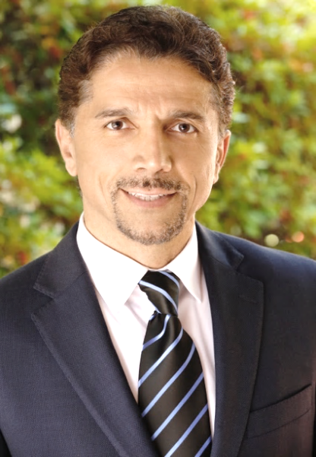**Lecturer:** Prof. Bahram Jalali (UCLA, Fellows of IEEE, OSA, APS and SPIE)

**Biography:** 光泵硅基激光器发明人，时域拉伸技术发明人，10年内发表2篇Nature，8篇Nature Photonics论文

Prof. Jalali is the Northrop-Grumman Endowed Chair and Professor of Electrical Engineering at UCLA with joint appointments in Biomedical Engineering, California NanoSystems Institute (CNSI) and Department of Surgery at the UCLA School of Medicine. He is the inventor of the Photonic Time Stretch, a measurement technique that has led to discoveries of new scientific phenomena and to technological inventions. He received his Ph.D. in Applied Physics from Columbia University in 1989 and was with Bell Laboratories in Murray Hill, New Jersey until 2002 before joining UCLA. He is a Fellow of IEEE, the Optical Society of America (OSA), the American Physical Society (APS) and SPIE. He is the recipient of the R.W. Wood Prize from Optical Society of America for the invention and demonstration of the first Silicon Laser, the Aron Kressel Award of the IEEE Photonics Society, the Achievement Medal from IET for his contributions to field of instrumentation for cancer detection, and the Distinguished Engineering Achievement Award from the Engineers Council. He was the founder and CEO of Cognet, a CMOS fiber optics company that was acquired by Intel in 2001. In 2005 he was elected into the Scientific American Top 50, and received the BrideGate 20 Award in 2001 for his entrepreneurial accomplishments and contributions to Southern California economy.

**Course Introduction:**

Real-time instruments with fine time resolution that acquire large data sets are needed for detection and classification of outliers such as optical rogue waves and cancer cells. Experimental challenges are many but the main one is the speed and resolution of real-time analog-to-digital converter (ADC). The most successful non-electronic method to overcome the ADC limitations has been the photonic time-stretch technology. Time stretch is a photonic hardware accelerator that has led to unprecedented performance in data acquisition and processing. Time Stretch has created experimental breakthroughs leading to observation of previously unobservable phenomena and is leading to new frontiers in measurement science and biomedical diagnostics. It has led to discovery of optical rogue waves and observation of other noise driven ultrafast dynamics such as fiber soliton explosion, observation of relativistic electron structure in accelerators and label free classification of cancer cells in blood with record specificity. Its further advances in the form of warped (Anamoprhic) stretch provides a tool for engineering the time-bandwidth of the signals, with direct utility in real-time data compression and data analytics.

This lecture series will start with an overview, followed by a tutorial on the physics and mathematical framework. It will cover applications of Time Stretch in data communication, spectroscopy, noise characterization, and the combination of time stretch with artificial intelligence for biomedical diagnostics. It will conclude with Phase Stretch Transform, a new digital image processing algorithm that has produced advances in super-resolution microscopy and in medical imaging.

**Schedule:**

|  |  |  |  |  |
| --- | --- | --- | --- | --- |
|  | 6th Dec. | 7th Dec. | 8th Dec. | 9th Dec. |
| 14:30-16:30 | **Overview** | **Mathematical Foundation** | **Applications** | **Future Directions** |

**Address:** Library 101 Conference Room at the Institute of Semiconductors, CAS

(中国科学院半导体研究所图书馆101会议室)

**Time:** 6th-9th December, 2016 (2016年12月6-9日)

**Contact**: Mr. Jian Tang (唐健)

**Email:**  [tangjian@semi.ac.cn](mailto:tangjian@semi.ac.cn)

**Phone:** 13261720893

**报名回执：截止日期11月15日，限50名（报满为止），课程免费，欢迎参加！**

|  |  |  |  |  |
| --- | --- | --- | --- | --- |
| **姓名** | **单位** | **职称** | **电子邮件** | **手机号码** |
|  |  |  |  |  |