黄昆半导体科学技术论坛

第309期讲座

报告题目: Chip-based Brillouin devices: Harnessing photon-phonon interactions in nanoscale integrated circuits
报告人: Prof. Benjamin J. Eggleton (School of Physics, University of Sydney, Australia)
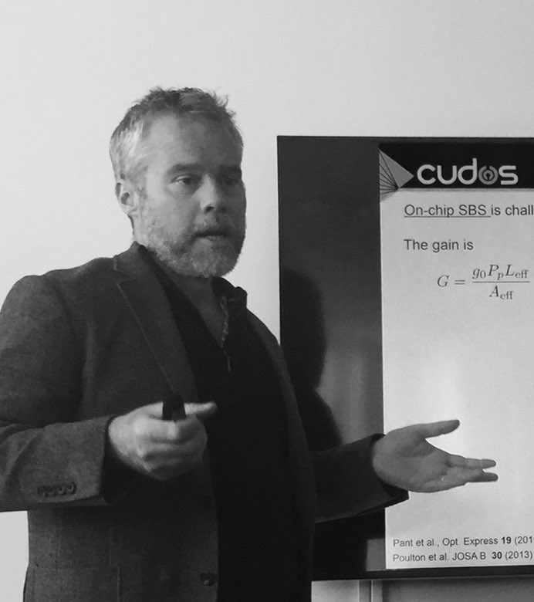
Abstract: One of the surprises of nonlinear optics – the field of optics with high intensity lasers – is that light may interact strongly with sound, the most mundane of mechanical vibrations. Intense laser light literally “shakes” the glass in optical fibres, exciting acoustic waves (sound) in the fibre. Under the right conditions, it leads to a positive feedback loop between light and sound termed “Stimulated Brillouin Scattering,” or simply SBS. This nonlinear interaction can amplify or filter light waves with extreme precision in frequency (colour) which makes it uniquely suited to solve key problems in the fields of microwave and optical communications amongst others. We recently achieved the first demonstration of SBS in compact chip-scale structures, carefully designed so that the optical fields and the acoustic fields are simultaneously confined and guided. This new platform has opened a range of new chip-based functionalities that are being applied in digital and analogue communications with record performance and compactness. This new Brillouin-device reveals new regimes of light sound interactions at the nanoscale, which has required new theoretical developments. My talk will introduce this new field, review our progress and achievements and recent highlights that point towards a new class of silicon based optical phononic processor that can be manufactured in semiconductor CMOS foundries.

报告人简介: Benjamin J. Eggleton，悉尼大学物理学院教授，悉尼大学光学与光子学研究所所长，ARC卓越中心主任，澳大利亚科学院院士，澳大利亚工程院院士，IEEE/OSA Fellow。他是APL Photonics主编、Optics Communications主编(2007–present)、IEEE Photonic Technology Letters副主编 (2003–2007)。他的主要研究领域是非线性光子器件和高速光器件。在Nature Photonics、Nature Physics、Nature Communications、Physical Review Letters等杂志上发表论文445篇，出版专著2部，授权专利35项。论文总引用超过18000次。

时间: 2017年10月24日（星期二）下午3：00
地点: 中国科学院半导体研究所5号楼四层LED会议室
联系人: 徐艳坤 82304453

