黄昆半导体科学技术论坛

**第307期讲座**

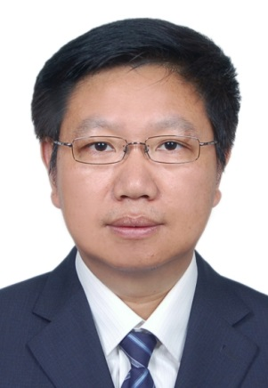报告题目：**Progress in Nanoscale Characterization and Manipulation**

报告人：王荣明 教授 (北京科技大学, 数理学院)

**Abstract:** Nanoscale characterization has enabled the discovery of many novel functional materials which started from understanding important relationships between material properties and morphologies. Therefore, nanoscale characterization has become an important research topic in nanoscience. It fosters the foundation for the design of functional nanodevices and applications of these nanomaterials.While nanomaterials find wider and more significant applications in almost every aspect of modern science and technology, researchers have been trying to gain detailed knowledge of novel materials with atomic (even sub-Å) scale resolution that are responsible for their unique properties, including chemical composition, atomic organization, coordinates, valence states, etc. This has been driving the development of ultramicroscopy. Here I will address the growing opportunities in this field and introduces the state-of-the-art charged-particle microscopy techniques, including conventional transmission electron microscopy, spherical-corrected microscopy and in-situ microscopy.

**个人简介：** **王荣明**，北京科技大学教授、博士生导师，数理学院院长，磁光电复合材料与界面科学北京市重点实验室主任。长期从事开展先进物质的界面精细结构设计、调控、表征和特性研究，在包括Phys. Rev. Lett.、Adv. Mater.、Angew. Chem. Int. Edit.、Nano Lett.等刊物发表SCI论文180余篇，被SCI论文引用超过6000次，论文引用H因子为42；应邀做学术报告60余次。兼任中国材料研究学会常务理事、纳米材料与器件分会秘书长、中国金属学会功能材料分会副主任等。曾获国家自然科学奖二等奖、教育部自然科学奖一等奖、中国材料研究学会科学技术奖一等奖、茅以升北京青年科技奖、北京市优秀博士学位论文指导教师等，被评为科学中国人（2012）年度人物，是享受国务院政府特殊津贴的专家。

**时间: 2017年10月12日(星期四)下午15:30**

**地点: 中国科学院半导体研究所2号楼303A会议室**

**联系人: 徐艳坤 82304453**