黄昆半导体科学技术论坛
第 321 期讲座
报告题目: New Physics and Model of Electrical Conduction of Pure Liquid Water and Potential Applications.
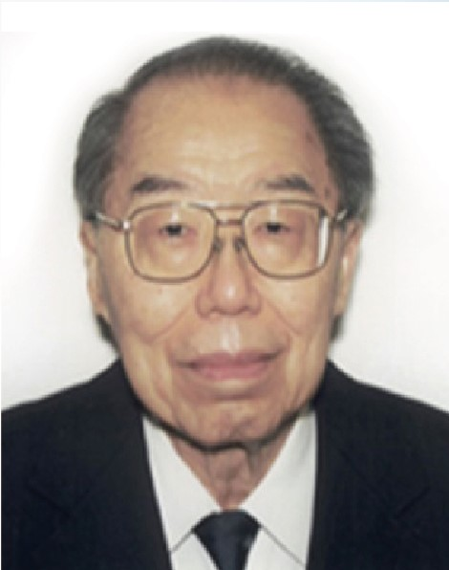
报告人: Prof． Sah Chihtang（萨支唐）
Prof． Jie Binbin （揭斌斌）
报告人简介：萨支唐，中科院外籍院士，美国国家工程院院士，台北中研院院士。1932年出生于清华园。清华物理学教授，厦大国立后首任校长。中科院前身中央研究院总干事兼物理所所长、中国物理学会创始人之一萨本楝的长子。现任厦门大学物理学教授。曾在美国两所高校任教半导体五十年（1961－2010），培养了50名博土生和指导合作了50名工业和学术博士后。他写了1633页三卷册教科书（1991－1993－1996），由复旦教授译成中文（2003）。他编辑了7本专著共3617页，是有关硅和复合半导体集成电路的二极和三极晶体管的发明历史和设计模型的，由16位邀请作者2007到2014年间写成，世界科技出版公司出版。这100位同学和他做出如下贡献1．Sah－ Noyce－ Shockley复合电流，2．Sah－ Shockley多电荷缺陷动力学，3．阻挡杂质扩散的氧化层掩模，4．来自杂质隧穿的多余电流，5．MOS晶体管表面势模型，6．CMOS集成电路，7．电流电容缺陷瞬态谱，8．I／f噪音理论和测量，9．I/(l+)噪音理论和测量，10．表面迁移率理论和测量，II．杂质赝势理论，12．界面和氧化层缺陷的氢钝化，13．浅能级杂质的氢钝化，14．界面缺陷直流测量（DCIV），15．完备晶体管理论，16．巨大MOS缺陷电容，17．水物理, 18. Foundation Physics.
揭斌斌，厦门大学萨本楝讲座物理教授。获得北京大学物理学学士（1986）和硕士学位（1989），新加坡国立大学电子工程博士学位（2000）。曾受聘为北京大学百人计划研究员（2006－2009）。自2001年以来，一直与萨支唐院土在科研和教学方面进行合作。
Abstract: Our 5-year study on the "abnormally high" electrical conduction in pure liquid water led us to the formulation of the successful Born-Von Karman lattice model of liquid water for protonic transport. Consistent with the Bernal-Fowler ice rule which was proven by Paulings Residual Entropy. Theory and Giauque's specified heat measurements, our hexagonal close packed lattice of Oxygen with tetrahedral point symmetry, extends through a considerable range of bulk liquid water, accounting for the Soft mechanical properties of the confined fluidic water. Each primitive unit cell of the Oxygen Lattice contains four water molecules, which is the basis of the many-body oxygenic or wateric photons and protonic phonons. The electrical charge carrier concentration and mobility of the point-mass protons in pure water can be represented by two self-consistent models: (1) the bipolar protonic energy band model of protons and prohols (proton-holes), in protonic materials, analogous to the bipolar electronic energy band model of electrons and holes in electronic solids and materials, (2 ) the unipolar (proholess) protonic energy band model with half (8) as many protons as (16) proton traps of three-charge-states. Bipolar and Unipolar protonic transports (drift-diffusion-trapping) are rate limited by mobile protons detrapping at the (16) dynamic proton-trapping centers, involving the absorption of only one protonic phonon in each detrapping transition, while its inverse, the trapping of the mobile proton with emission of also one protonic phonon, has a much higher rate. Between the trapping and detrapping transitions, the mobile protons are scattered by wateric phonons with a distribution of energies (Debye Mode). The international standard experimental generation-recombination-trapping data of the 50-year-old ion product (or PH) at thermodynamic equilibrium and the 40-year-old mobilities of the two ions at small deviation from thermodynamic equilibrium, and the reported experimental phonon energies, are used by us to extract the ion and proton concentrations and proton mobilities, anticipated by our water physics and its model. Some important potential applications of our water physics and model are described.
报告时间：2018年5月30日上午9：30
报告地点：中科院半导体研究所学术会议中心
联 系 人：徐艳坤 82304453

